Loading Images into EnviroCOMS DAM.

1. Log into Envirocoms

<http://tdh-envirocoms-1.hpc.jcu.edu.au/login>

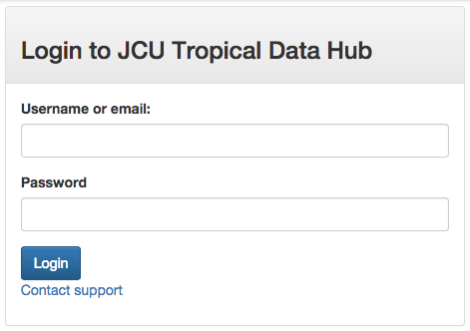

1. Select ‘Mangrove Watch’ as the organization.

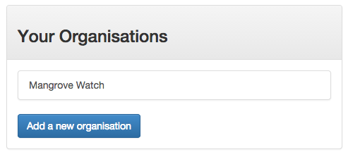

1. Create a Project

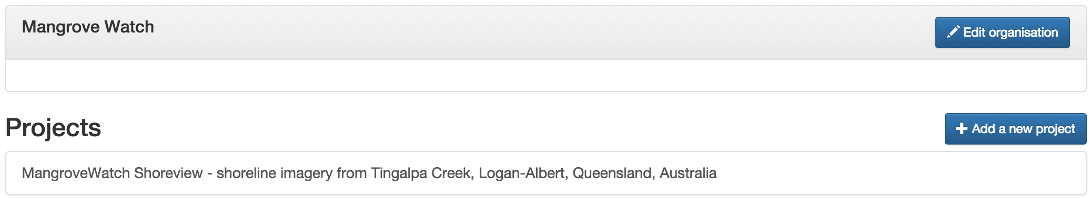

Click on ‘Add a new Project’

A new project should be created for each new location to be annotated in Shoreview (Catami).

As historical data is created for the same location, this should be treated as a new Dataset, not a new project. See Step 5 below.

Complete all the fields. These project details will be used to create metadata records in [ResearchData](https://research.jcu.edu.au/researchdata) to provide improved discoverability of the data.

1. Submit the ‘Project’
   1. Click on the project
   2. Click on Redbox. (left column)

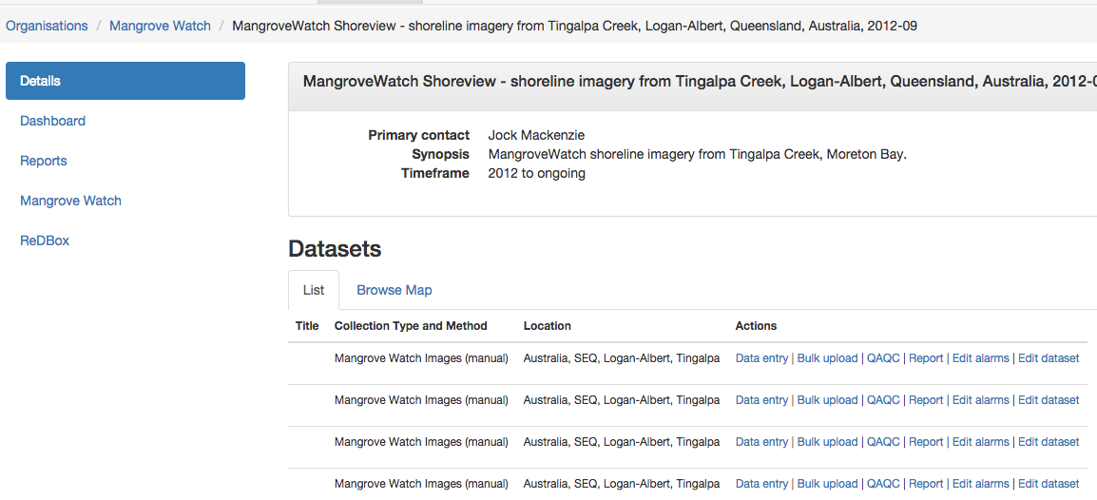

* 1. Click on Submit

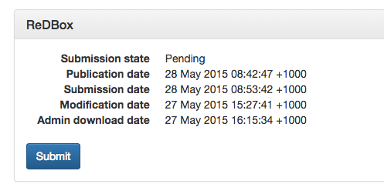

This notifies the [Researchdata](https://research.jcu.edu.au/researchdata/) Administrator that a record is ready for submission. The metadata record will appear under the ‘Data’ tab in your JCU profile at <http://jcu.me>

1. Import the Data
   1. Click on the Project



* 1. On the left side of the screen, click on ‘Mangrove Watch.

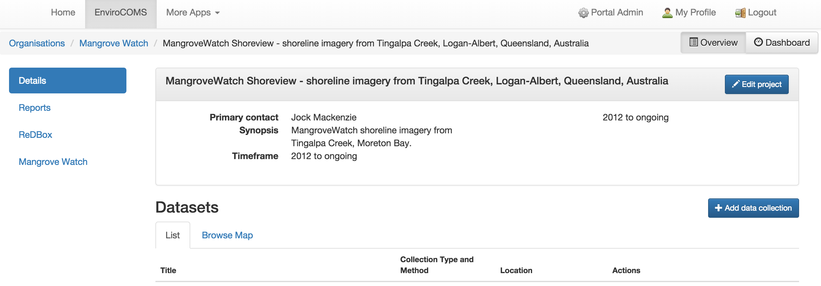

* 1. Under ‘Data Folder’, click ‘Organized’.

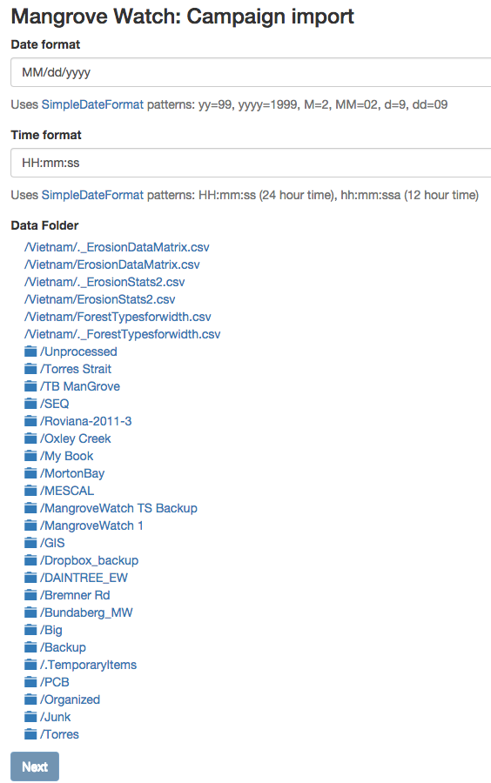

The **Organized** folder contains a structure of all the organized data. Only import from here.

The following path is an example structure for organizing/tidying up the Mangrove data.

Organized/SAMPLE-Country/Region/Catchment/Place/YYYY-MM/processed/frames

This structured was designed so a consistent approach to storing the Mangrove Watch data can be developed over time.

Here is a real example path of processed frames for loading into EnviroCOMS.

Organized/Australia/SEQ/Logan-Albert/Tingalpa/2012-09/processed/frames

This frames folder contains a spreadsheet named ‘Template - TingalpaCK_Video_Data_130416.xlsx’.

* this spreadsheet has been designed to use as a way to create a CSV file for importing data into EnviroCOMs.
* Use this spreadsheet for other trips to create a correctly formatted CSV file. (Note, ensure the CSV created from the spreadsheet contains valid data, if not this can cause the import process to fail.)
* You will require access to the Mangrove Watch RDSI storage to create/save the CSV file.

The .CSV contains the geo spatial data for each frame.

The import process expects the images to be located in the same folder/sub folders as the .CSV file.

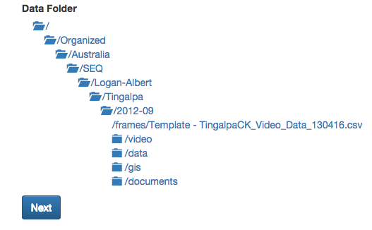

Click on ‘/frames/Template – TingalpaCK_Video_Data_130416.csv’

* 1. Click ‘Next’.

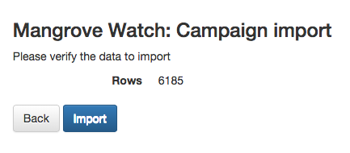

* 1. Click ‘Import’



Please wait until complete. The button will say ‘Importing…’.

This can take a while.

Once the frames have successfully been import, you will see a new dataset.

*Note: the new dataset will not have a Title.*

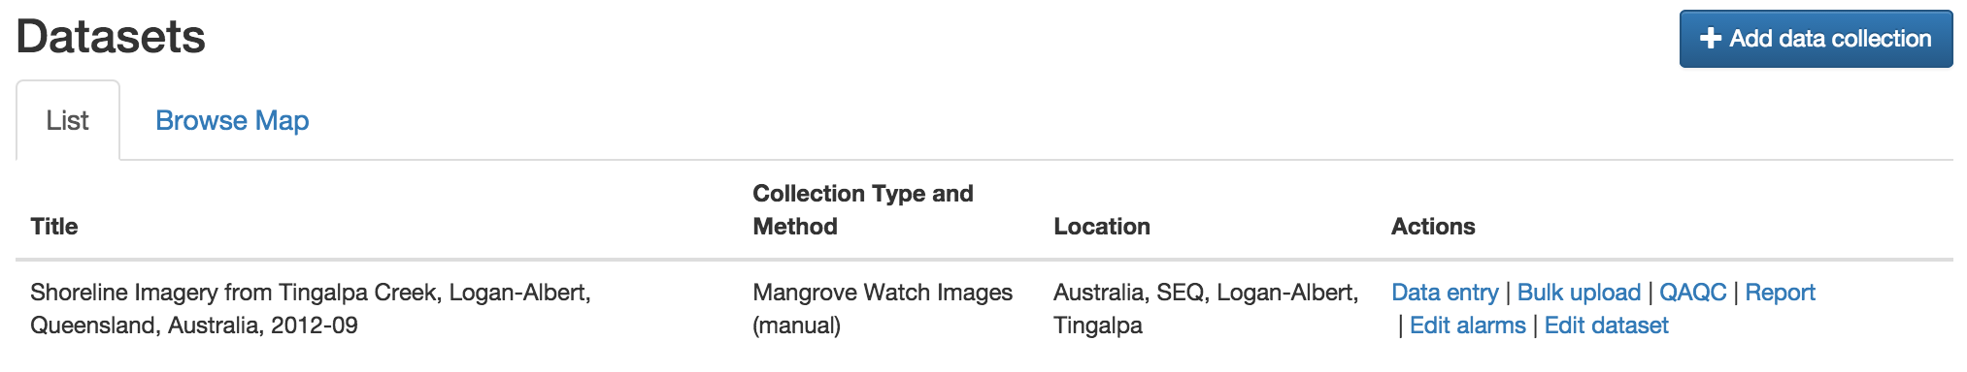

* 1. Give the dataset a title. Click on Edit dataset

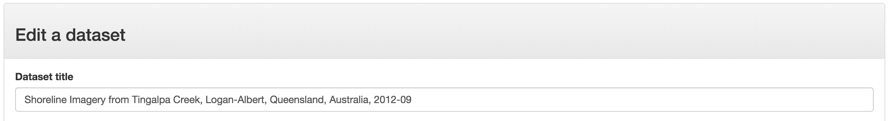

Note: the Dataset title becomes the ‘Deployment’ in Shoreview.

The naming convention adopted is the same as the project, with the date appended on the end.

*Shoreline Imagery from Tingalpa Creek, Logan-Albert, Queensland, Australia, 2012-09*

* 1. Click on Save.

1. Login to Shoreview as Administrator
2. Go to <https://rdsi-mangrove.hpc.jcu.edu.au/ecoms_sync/>

This will synchronise Shoreview with EnviroCOMS, creating new Campaigns/Deployments where required.